What if safety didn’t come from the network…

but from identity itself?
🧠 Kids are either overexposed… or over-controlled.
Parents are forced to choose between safety and trust.
Most tools either spy… or fail.
🔄 SIGEAR replaces the model.
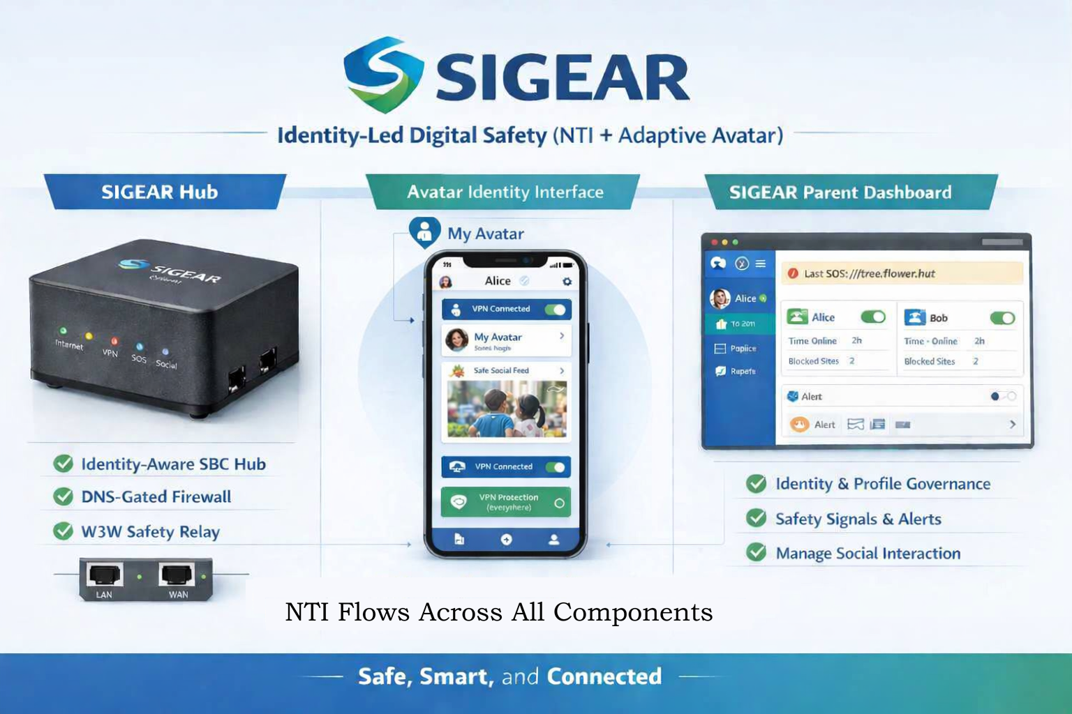
💡IDEA
Each user has a secure identity (NTI),
paired with an adaptive digital companion that:
- understands who they are
- applies what’s appropriate
- guides what happens next
⚙️ SYSTEM  Designed to grow with the user  - Works at home  - Works anywhere  - Stays consistent everywhere | 🔐 DIFFERENCE  Nothing is exposed. Only decisions are shared.  - No passwords  - No data sharing  - No surveillance
🧠 This isn’t control…It’s understanding.

📦 OPTIONAL FOOTER BLOCKS
(Use these depending on where I post.)
About SIGEAR
Identity-led digital safety for families, educators, and young people.
Powered by NTI and adaptive digital companions.
Call to Action
Choose one depending on the platform:
- Looking for collaborators — engineers, designers, researchers.
- Open concept. Open governance. Open to contributors.
- See the full concept + docs on GitHub.
- Help shape the future of digital safety.
Links Section
- GitHub Repo: [your link]
- Concept Docs: [your link]
- Diagram Pack: [your link]

